EXP-3A
CODE:3A
clc;
clear;
close all;
% Parameters
Am = 3; % Message Amplitude (V)
fm = 200; % Message Frequency (Hz)
Ac = 8; % Carrier Amplitude (V)
fc = 3000; % Carrier Frequency (Hz)
fs = 20*fc; % Sampling Frequency (Hz)
kp = pi/4; % Phase Sensitivity (rad/V)
% Time Vector
t = 0:1/fs:4/fm;
% Message Signal
m = Am*sin(2*pi*fm*t);
% Carrier Signal
c = Ac*cos(2*pi*fc*t);
% Phase Modulated Signal
pm = Ac*cos(2*pi*fc*t + kp*m);
% Phase Deviation
phase_dev = kp*Am;
% PM Modulation Index
mp = phase_dev;
% Display Results
fprintf('Message Amplitude = %.2f V\n', Am);
fprintf('Message Frequency = %.0f Hz\n', fm);
fprintf('Carrier Amplitude = %.2f V\n', Ac);
fprintf('Carrier Frequency = %.0f Hz\n', fc);
fprintf('Phase Sensitivity = %.2f rad/V\n', kp);
fprintf('Phase Deviation = %.2f radians\n', phase_dev);
fprintf('PM Modulation Index = %.2f\n', mp);
% Plotting
figure('Name','Phase Modulation and Phase Deviation','NumberTitle','off');
subplot(2,2,1);
plot(t,m,'LineWidth',1.5);
title('Message Signal');
xlabel('Time (s)');
ylabel('Amplitude');
grid on;
subplot(2,2,2);
plot(t,c,'LineWidth',1.5);
title('Carrier Signal');
xlabel('Time (s)');
ylabel('Amplitude');
grid on;
subplot(2,2,3);
plot(t,pm,'LineWidth',1.5);
title('Phase Modulated Signal');
xlabel('Time (s)');
ylabel('Amplitude');
grid on;

subplot(2,2,4);
bar(phase_dev);
title('Phase Deviation');
ylabel('Radians');
set(gca,'XTickLabel',{'PM Signal'});
grid on;

OUTPUT:
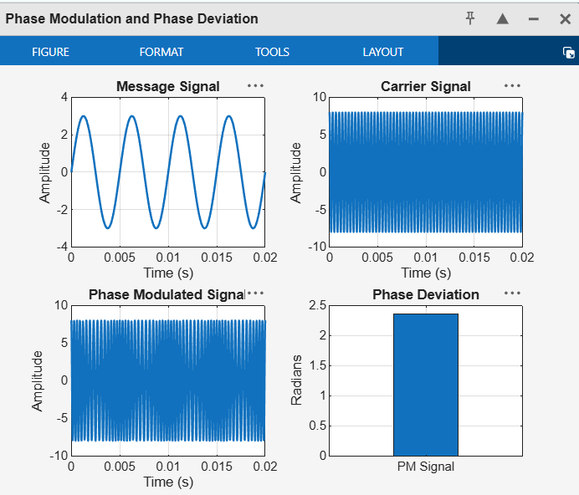

CODE:3B
clc;
clear;
close all;
% Parameters
Am = 2; % Message Amplitude (V)
fm = 200; % Message Frequency (Hz)
Ac = 8; % Carrier Amplitude (V)
fc = 2500; % Carrier Frequency (Hz)
fs = 25*fc; % Sampling Frequency (Hz)
kp = pi/3; % Phase Sensitivity (rad/V)
% Time Vector
t = 0:1/fs:5/fm;
% Message Signal
m = Am*sin(2*pi*fm*t);
% Phase Modulated Signal
pm = Ac*cos(2*pi*fc*t + kp*m);
% Phase Deviation
beta = kp*Am;
% FFT
N = length(pm);
f = linspace(-fs/2, fs/2, N);
PM_FFT = abs(fftshift(fft(pm)))/N;
% Power Spectral Density
PSD = (abs(fftshift(fft(pm))).^2)/(N*fs);
% Estimated Bandwidth (Carson's Rule Approximation)
BW = 2*(beta+1)*fm;
fprintf('Phase Deviation = %.2f radians\n', beta);
fprintf('Estimated Bandwidth = %.2f Hz\n', BW);
% Plotting
figure('Name','PM Signal Analysis','NumberTitle','off');
subplot(2,2,1);
plot(t,m,'b','LineWidth',1.5);
title('Message Signal');
xlabel('Time (s)');
ylabel('Amplitude');
grid on;
subplot(2,2,2);
plot(t,pm,'r','LineWidth',1.2);
title('Phase Modulated Signal');
xlabel('Time (s)');
ylabel('Amplitude');
grid on;
subplot(2,2,3);
plot(f,PM_FFT,'k','LineWidth',1.2);
title('Frequency Spectrum');
xlabel('Frequency (Hz)');
ylabel('Magnitude');
grid on;
subplot(2,2,4);
plot(f,PSD,'m','LineWidth',1.2);
title('Power Spectral Density');
xlabel('Frequency (Hz)');
ylabel('PSD');
grid on;
OUTPUT:
